You shall have no other gods

A god is that to which we look for all good in which we find refuge in every time of need. To have a god is nothing else than to trust and believe in him with our whole heart. If your faith and trust are right, then your God is the true God. On the other hand, if your trust is false and wrong, then you do not have the true God.
Luther's Large Catechism, Commandments, 2,3
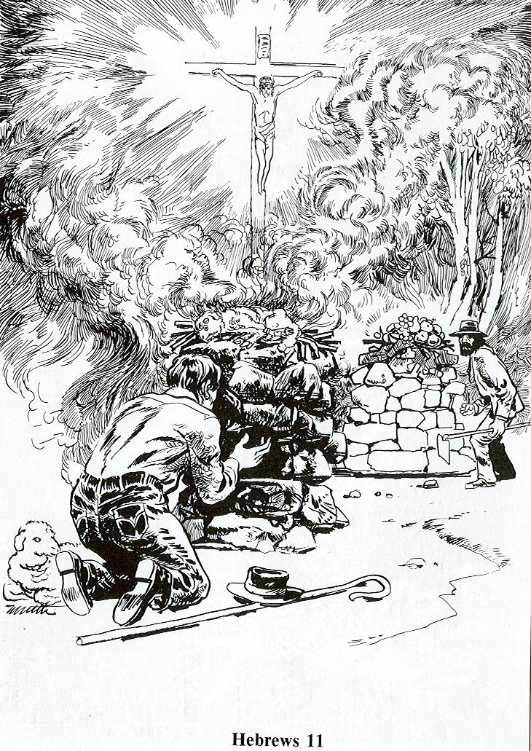
Read Genesis 4:2-5; Hebrews 11:4
1. Compare Cain’s offering with Abel’s.
- What is similar about them?
- What is different?
2. Describe Cain’s attitude toward the LORD as you look at the picture.
3. Describe Abel’s attitude.
4. Discuss: When is my attitude like Cain’s? When is it like Abel’s?

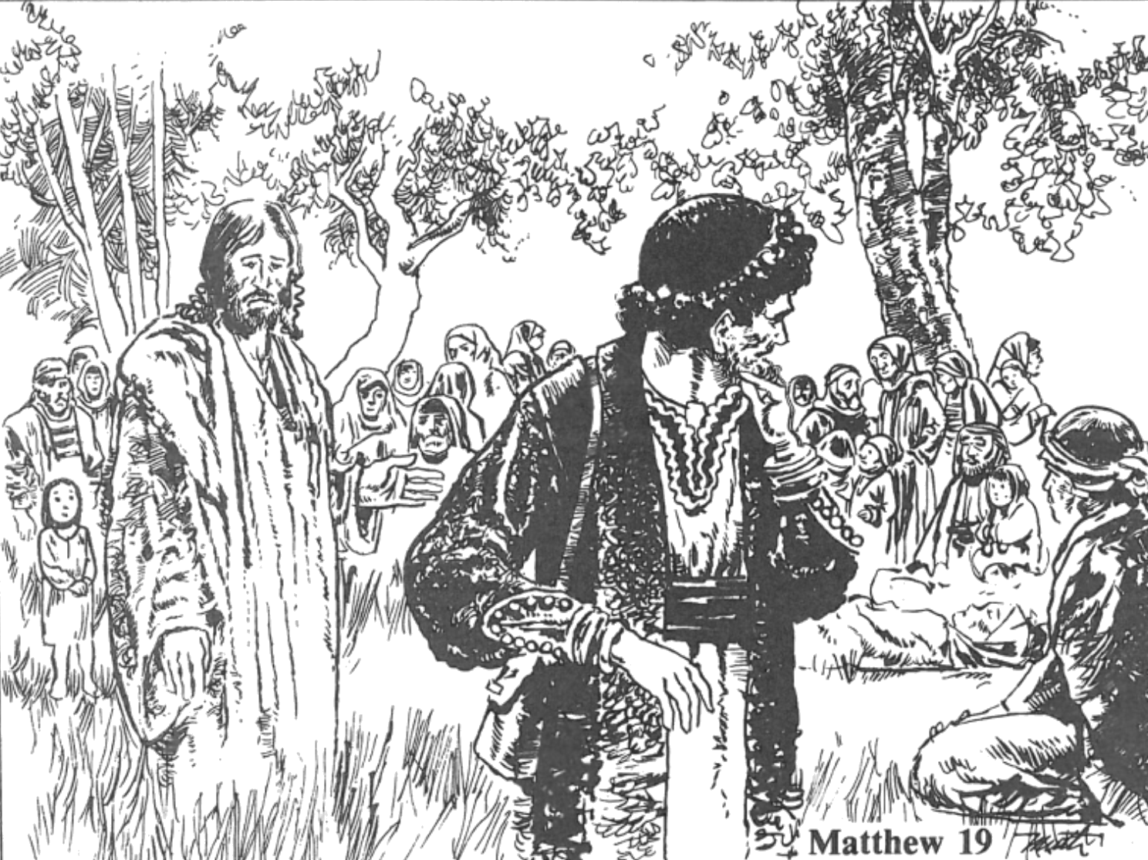

Read Matthew 19:16-26
1. What did the young man want to know?
2. What did Jesus tell him?
3. What did the young man think he had done?
4. What did Jesus tell him to do if he wanted to be perfect?
5. How did the young man feel when he heard Jesus' answer?
6. In your group, name one thing that would be difficult for you to give up.
What makes it so difficult?

What are my idols?
- Where does your mind wander most often during alone or down time?
- What good thing have you turned into an ultimate thing?
- What do you spend most of your money and time on?

